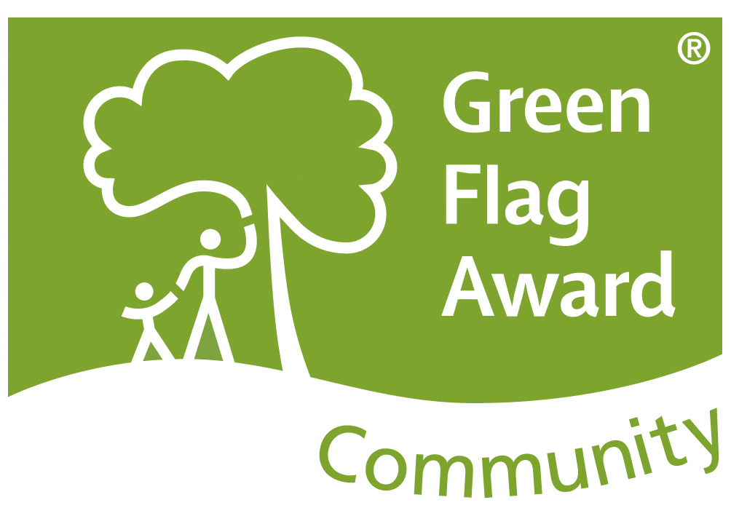
FRIENDS OF SUNNY BANK VALE
NEWSLETTER NO. 22 – SPRING 2025

Spring has sprung on the Vale in all its glory, helped by the wonderful weather over the past few weeks. The new bird boxes the Friends put in place over the Winter months are now occupied and everywhere there is a vibrant new growth, and the insects are buzzing. The increased footfall recently again emphasizes the importance of this vital green space not only for recreation but as the only means of accessing the lower entrance on Edge Lane as the Fairy Steps appear to be closed permanently to the general public and there is no access.

The Vale has seen much activity over the past 12 months, the Family Fun Day and the Bat Walk were well attended and enjoyed by all. The Group has engaged with The Medlock Species Survival Fund Project, which includes Groundwork and the Manchester City of Trees. They have undertaken woodland management and have cleared a large amount of fly tipped rubbish. They have also worked with the Friends group to help create a wetland area which will enhance the wildlife and the surrounding environment. The old flowerbed at the main entrance from Greenside Lane has been completely redesigned, using recycled materials, and this has greatly improved the area with the metal fence and gate also repainted.

The eradication by Ebsford Environmental Ltd of the Japanese Knot Weed continues into this year, the final phase. It has proved very successful and although the areas affected, namely Collingwood, Peakdale, the path by the old recreation ground and the very large patch close to the pond may look unsightly in time we will be able to improve them.

We were again awarded another “Outstanding” Britain in Bloom Community Award and a Community Green Flag Award and a big thank you goes to all our volunteers who enable this to happen. We should also thank Mick Brickell and his team from the Together Centre who maintain the grass verges on our behalf and John Smith and his team from Tameside Operations and Greenspace (who collect the rubbish that the Friends collect).

Lastly, we have to thank the organisations who have funded us over the past 12 months, without their help we would not be able to operate as we do. These include Bradley Park Community Fund, Grantscape, Tameside MBC West Ward Councillors and Tameside Rotary Club.

We hope that you will continue to enjoy using Sunny Bank Vale over the coming months.
friendsofsunnybankvale@gmail.com
www.friendsofsunnybankvale.weebly.com we also have Facebook page

